MiCS-2710 Response to NO2: Model I

Manufacturer's specification
Here is a copy of a spec sheet for the MiCS-2710, obtained from http://airqualityegg.wikispaces.com/file/view/MICS-2710+-+NO2pdf. It's a line between two points on a log-log scale. Ro is resistance in “air”. Rs/Ro is the ratio of the resistance of the sensor, Rs, to that reference value.
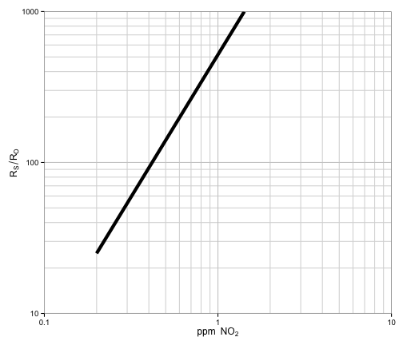

Same plot, with the axes flipped so that Rs/Ro becomes the independent variable.
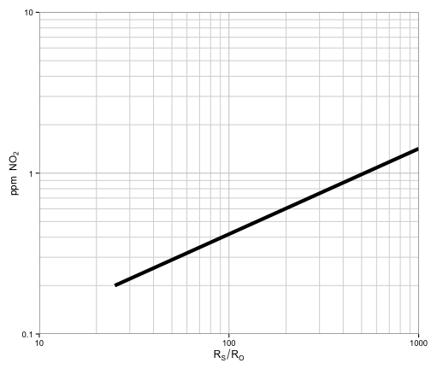

Logarithmic extrapolation
When Rs/Ro = 1, we are measuring “air”. Air isn't precisely defined, but on the plot above, an Rs/Ro of 1 corresponds to about 0.036 ppm NO2. This sounds about right. In urban areas in the United States, typical hourly ambient concentrations of NO2 are on the order of 0.010-0.100 ppm, and the standard for the maximum annual average is set at 53 ppb, or 0.053 ppm.
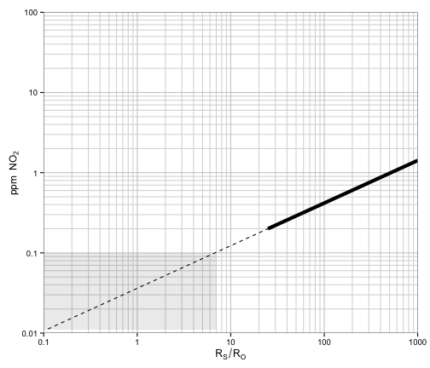
Same range of Rs/Ro, but now with arithmetic scales. The NO2 scale has been seriously zoomed. The region of interest indicated by the gray box is still squashed into the lower-left corner.
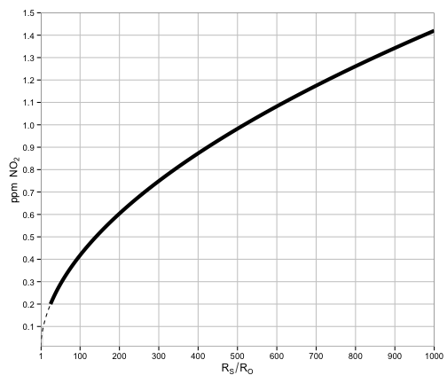

Zooming in to the lower left corner, still with arithmetic scales.

Generating values
For those who want to play around, and like to use a different plotting tool, here's R code to construct a forward model (from RsRo to ppm) and an inverse model (from ppm to RsRo).
MiCS2710_spec <- data.frame(
ppm = c(0.20, 1.42),
RSR0 = c(25, 1000)
)

MiCS2710_ppm <- function(RSR0) {
model <- lm(ppm ~ RSR0, data=log10(MiCS2710_spec))
10 ** predict(model, data.frame(RSR0=log10(RSR0)))
}

MiCS2710_RSR0 <- function(ppm) {
model <- lm(RSR0 ~ ppm, data=log10(MiCS2710_spec))
10 ** predict(model, data.frame(ppm=log10(ppm)))
}
You can use these to generate arbitrary ranges of points, for your own curves, and save them to a CSV file.
# Start with either ppm or RSR0
ppm <- seq(from=0.001, to=0.100, by=0.001)

# Use the corresponding function to generate the other variable
RSR0 <- MiCS2710_RSR0(ppm)

# Bind them together and save to a CSV file
data <- data.frame(RSR0, ppm)
write.csv(data, file='mydata.csv', row.names=FALSE)

Linear extrapolation
Suppose our model of sensor response at low concentrations is (piecewise) linear, rather than logarithmic, and goes straight from the lower bound of the manufacturer's curve to zero.
x0 <- with(MiCS2710_spec, min(RSR0))
y0 <- with(MiCS2710_spec, min(ppm))
f <- function(x) (y <- x * y0 / x0)
data <- data.frame(RSR0=seq(0, x0, by=0.1))
data <- transform(data, logarithmic=MiCS2710_ppm(RSR0), linear=f(RSR0))
head(data)
## RSR0 logarithmic linear
## 1 0.0 0.0000 0.0000
## 2 0.1 0.0106 0.0008
## 3 0.2 0.0154 0.0016
## 4 0.3 0.0191 0.0024
## 5 0.4 0.0222 0.0032
## 6 0.5 0.0250 0.0040
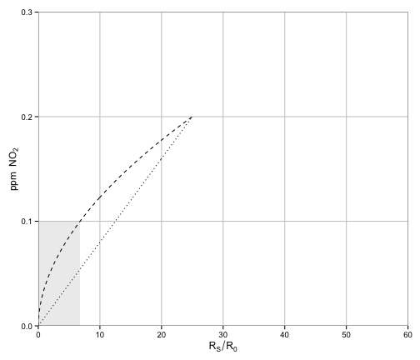
So, if the logarithmic curve is the “true” curve, then this method would result in an underestimate of the “true” concentration. We can look at the average difference, in ppm, over the region of interest.
difference <- function(x) MiCS2710_ppm(x) - f(x)
ratio <- function(x) MiCS2710_ppm(x) / f(x)

integrate(difference, 0.01, x0)$value / (x0 - 0.01)
## [1] 0.0306
integrate(ratio, 0.01, x0)$value / (x0 - 0.01)
## [1] 1.85
On average, there's about a 2x difference on a ratio scale, or +0.031 on an arithmetric scale. That's not entirely fair, since not every value in the region of interest is equally probable, but it's a start.

Caveat
NEITHER method is guaranteed to be appropriate. Both are extrapolations with no support from nearby data. The point of collecting calibration data in this range is to figure out what the RIGHT function looks like—as well as how much error to expect (which hasn't been discussed) from measurement to measurement, and from sensor to sensor.

MiCS-2710/2714 Sensor: Model II
For comparison, here is a different curve (thin line) for NO2 response for the MiCS2710/2714 obtained from http://airqualityegg.wikispaces.com/file/view/e2v+Mics+SensorCharacterizationData.pdf. The response curve from the figures above (thick line) has also been plotted. We're back on a log-log scale with NO2 (not Rs/Ro) as the independent variable.
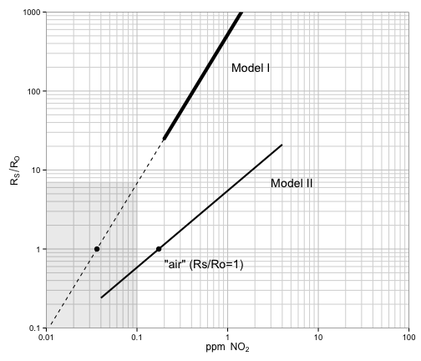
Two questions:
- What accounts for the drastic difference between the two curves? Both are supposed to apply to the MiCS-2710, correct? Are the temperature and humidity conditions the same?
- Why, in model II, does RsRo=1 (that is, “air”) correspond to an NO2 concentration of over 100 ppb? This is more than twice the average hourly concentration at most “regional” monitors in developed countries. (I'm most familiar with the US, and I'm not certain what the average is in, say, Delhi, or Beijing, though one could try to find this out. In any setting one can definitely find higher concentrations on or near highways.)

