UTS BB Embedded Sensors
Data-Logging Methodology
Author: Ray Clout
Strain Gauge Type: WFLA-6-11 by Tokyo Sokki Kenkyujo Co. Ltd.
Gauge Factor: 2.10 +/-1%
Gauge Resistance: 120Ω

The strain gauges installed in the new Broadway Building are routed via a 3-core cable back to a data-logger.
The data-logger is the DT80 by Data Translation.
For connection to the data-logger, a 3-wire compensation circuit is used for 3 wire resistance measurement (see Fig. 1)
In the 3 wire measurement, excitation current flows out of the logger, through the excite wire, through the resistance being measured, and back via the return wire. A measurement is then made, and, using the third “sense” wire, the negative end of the resistance being measured. This measurement includes the voltage drop across the excite wire, as well as the unknown resistance.
The 3 wire compensation circuit works by measuring the voltage drop across the return wire, multiplying it by 2 (to account for the voltage drop in the excite wire, which is assumed to be equal to that in the return wire., then using this voltage to offset the negative input of the instrumentation amplifier. This will effectively subtract the cable’s voltage drop, thereby compensating for the effect of the cable resistance.
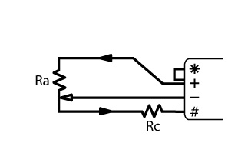
Fig. 1
For a 1/4 bridge, Ra can be a single strain gauge and Rc can be either a precision bridge completion resistor or a temperature compensation gauge.

Measured values are saved to a csv file in ppm format.
To convert from ppm to micro-strain, use the following:
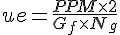
Where:
µe = Microstrain
Gf = gauge resistance (120Ω)
Ng = number of active gauges (1)
Note; A gauge is active if it is being stressed by loads applied to the structure. A temperature compensation gauge is not considered as an active gauge.

